We need your help in getting the word out about Artists Count: San Diego + Tijuana!

A landmark binational initiative to strengthen and grow the region’s arts sector through investment in artists and research on the region’s creative workforce, Artists Counts has two components:
- $1.3 million in funding and professional development opportunities for artists
- A research effort to better understand the realities, challenges and economic impact of working artists in San Diego and Tijuana – with particular focus on underserved communities.
Artists Count is led by San Diego ART Matters and the International Community Foundation, in partnership with the Prebys Foundation and the City of San Diego Cultural Affairs.

Please help us spread the word on the funding opportunities and the artists’ research survey.

Here is content you can use on your social media accounts, e-newsletters/e-blasts or websites to help us reach artists across San Diego County and Tijuana:

Sample Content for Website or Eblast
Dancers, photographers, painters and all artists: Your story matters. Your art matters. And now, there's $1.3 million invested in proving it.

Artists Count: San Diego + Tijuana is here for working artists, especially those in underserved communities. Apply for direct funding (May 15 deadline!) and professional development and take the artists’ survey to help shape the future of our creative region.

Every artist who applies and completes the research survey helps build lasting support for artists across San Diego and Tijuana.

@San Diego ART Matters and @International Community Foundation, in partnership with @The Prebys Foundation and the @City of San Diego Arts and Culture, launched Artists Count.

👉 Get started at ArtistsCount.org

#ArtistsCountSDTJ

Instagram
Artists, your work matters — and now, there's $1.3 that proves it. 🎨

Artists Count: San Diego + Tijuana is here to invest in YOU. Apply for funding (May 15 deadline!) and professional development and help shape the future of our creative economy with our artists' survey.

@SDARTMatters and @ICFDN, in partnership with @PrebysFound and @SDArtsCulture, launched Artists Count, a binational initiative to provide funding and professional development, plus binational research to better understand and support working artists – especially in underserved communities.

Every artist who applies and participates in the research survey helps build a stronger case for lasting support across our region.

👉 Get started at our link in bio.

#ArtistsCountSDTJ

LinkedIn
San Diego. Tijuana. One creative region — where artists’ stories deserve to be counted.

Artists Count: San Diego + Tijuana is investing in working artists through direct funding (May 15 deadline!), research, entrepreneurship training and cross-border connection.

@SD ART Matters and @ International Community Foundation, in partnership with @Prebys Foundation and @The City of San Diego Cultural Affairs, have launched Artists Count, a binational initiative offering funding and professional development, and a survey to better understand and support working artists — especially in underserved communities.

👉 We need you. Please review the criteria for funding and take the artists’ survey. Visit ArtistsCount.org to get started.

#ArtistsCountSDTJ

X/Bluesky
San Diego + Tijuana artists: this one's for you. 🎨

Artists Count is investing in working artists through direct funding, professional development and binational research. Apply, take the survey and help shape the future of our creative community.

👉 ArtistsCount.org

#ArtistsCountSDTJ

Visuals
Please use the logos with reference to Artists Count. Flyers and other materials here.

English:

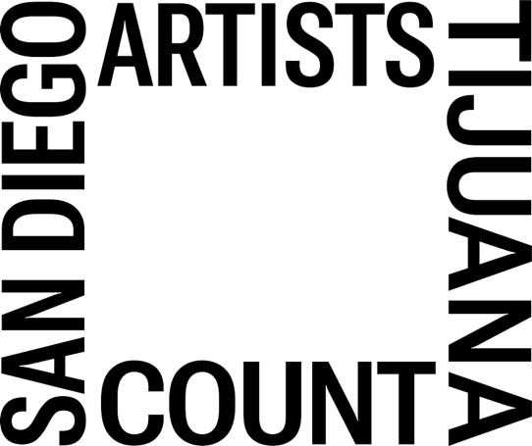

Spanish:

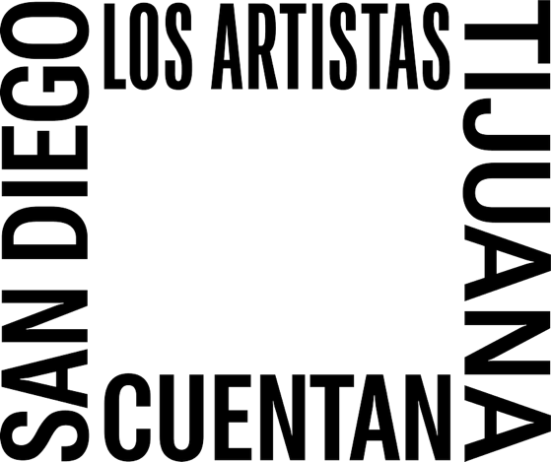

Partners
- San Diego ART Matters: https://sdartmatters.org/
- International Community Foundation: https://icfdn.org/
- Prebys Foundation: https://www.prebysfdn.org/
- City of San Diego Cultural Affairs: https://www.sandiego.gov/economic-development/cultural-affairs
- The Parker Foundation: https://theparkerfoundation.org/
- Policy & Innovation Center: https://thinkpic.org/

